## Sean Kennedy – Database Design HW2

## Q1:

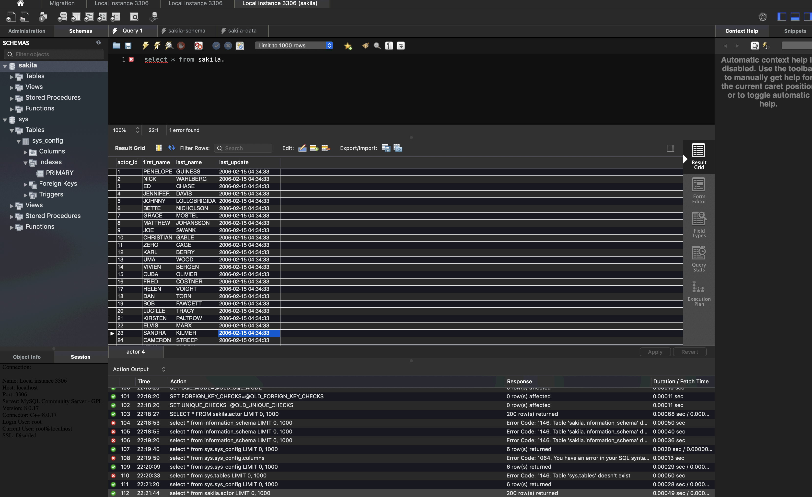

## Q2:

The database is a collection of information for a movie rental business. Tracking the metadata of each film (actors, release dates, categories, language). It also tracks information on customers (addresses, payments, rentals), employees and the store as a whole (manager etc)

It implements a few one-to-many relationships (movie/actor and category/movie) through the use of foreign keys. The tables seem to be designed well from a key standpoint – lots of primary/foreign key relationships.

It also contains various stored procedures and views for consuming data without interacting with the underlying tables. There are a few functions defined on the db as well. Basically, this DB contains most of the data/metadata that you would need to operate a video rental business back in 1995 ☺

## Q3:

